FAQ
- Who can add or modify users?
  - One or more district individuals can be assigned User Access role to manage who can view and work in unapproved plans and grant applications for their district only. This person can add users; add and delete roles for a user, initiate a new password or modify user information.
  - Any user can modify their own information and reset their passwords.
- Can a user have multiple roles?
  - Yes, a role is a permission set, not a job title. In some districts, the finance officer may have the authority to approve an application for the superintendent. In this case, (s)he would be given the District Finance Officer role and the District Superintendent role.
- Can multiple users have the same role?
  - Yes. For example, several people could have the same role that would give them the ability to approve an application as a superintendent, finance officer or funding application director.
- Can a user be deleted?
  - No. Because most activities are tracked by user, all users stay in the system in order to maintain activity records. However, a user can be inactivated by removing all roles assigned to the user.
- Why didn’t a new user get an email to set a password?
  - If the email address for a new user is correct, it could be that the email was routed to a junk folder. Have the user check there.
  - If the email address for a new user is incorrect, the password email will be sent to that incorrect address. In that case, the user access administrator will correct the email address and click the link to Reset the password so that a new email will be sent.
- What are the permissions of the different roles?
  - Permissions are determined by 1) the district assigned and 2) the role assigned. KDE roles have access to all districts. District roles have permissions only for the district to which they are assigned.
Role | User Access Administration | Consolidated Funding Application | Perkins Funding Application | Planning Tool CDIP | Planning Tool CSIP
User Access Administrator | Edit | View | View | View | View
District Data View | None | View | View | View | View
District Consolidated Update | None | Edit | View | View | View
District Consolidated Director | None | Edit and Mark Completed | View | View | View
District Perkins Update | None | View | Edit | View | View
District Perkins Director | None | View | Edit and Mark Completed | View | View
District Finance Officer | None | Edit and Give Finance Officer Approval | Edit and Give Finance Officer Approval | View | View
District Superintendent | None | Edit and Give Superintendent Approval | Edit and Give Superintendent Approval | View | View
District Plan Data Entry | None | View | View | Edit | View
District Plan Submitter | None | View | View | Edit and Mark Completed/Approved | View
School Plan Data Entry | None | View | View | View | Edit
School Plan Submitter | None | View | View | View | Edit and Mark Completed
Note: Approved plans and grant applications are visible to anyone, including the public.

- Can a user work in multiple districts?
  - Yes. A KDE User Access administrator can assign a user to multiple districts by choosing the districts and the roles. District User Administrators can allow someone outside the district who has a GMAP ID to have a a role within their district.
- Must a person have a role to view the applications?
  - Anyone can view a final approved application for any district without having a role or a user ID in the system. However, a person must have a user ID and appropriate role to view unapproved applications.

- Creating Users
- Go to Administer on the main menu and select User Access function. (This menu item will only appear for persons with User Access Role.) |  | 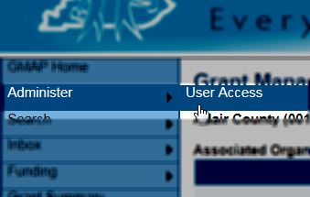
- The User Access page allows you to search for an existing user and has a link to create new users. Select Create User. |  | 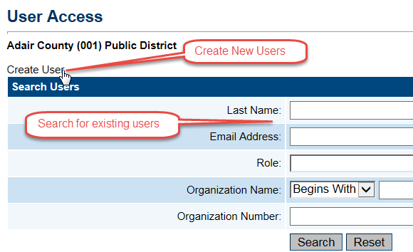
- Enter at a minimum the email address, first name and last name. |  | 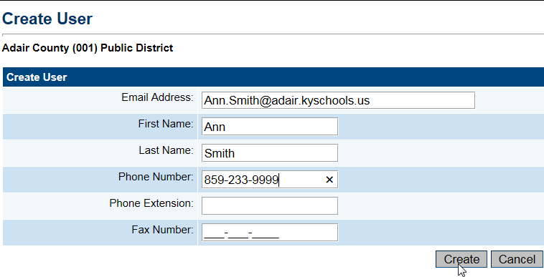
- Passwords
- The GMAP system will send an email to the user’s email address when the user is created. It has a link that allows them to set their own password.  - User access administrators can also initiate a new email for a password by selecting Reset Password for a user.  - If an existing user needs a new password they will use the Forget your password? link on the login page and the system will send an email which will allow them to set a new password.  - Existing users can reset their password from their user profile. |  | 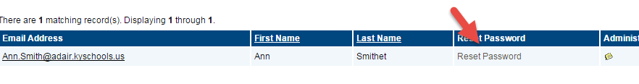  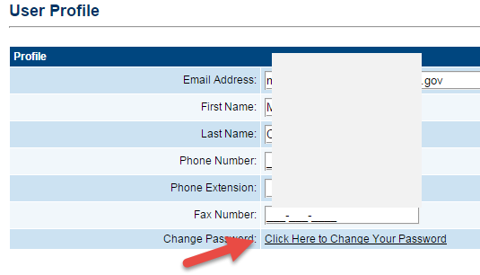
- Assigning Roles
- The system next displays the Administer Roles page. Click on Create Role. |  | 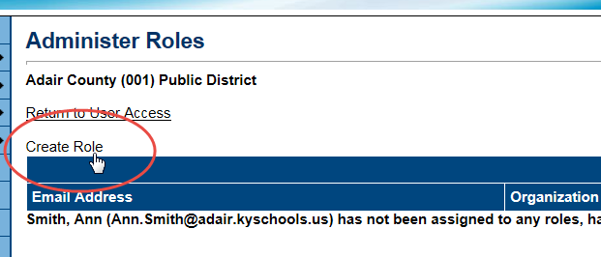
- Select a role for the user using the drop down box and click on the Create button.  - Note: for grant application users leave the school selection at ALL |  | 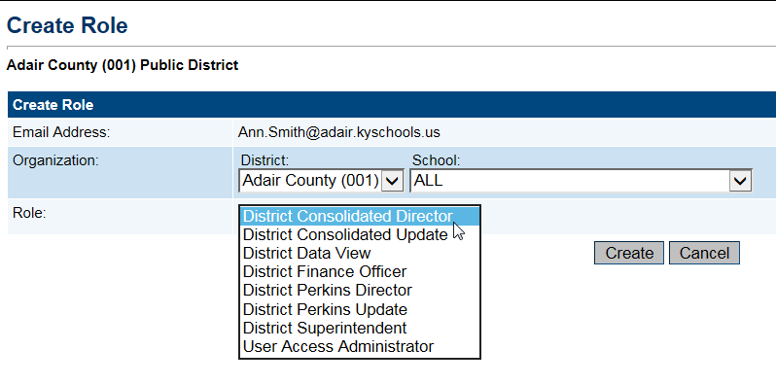
- The system will return you to the Administer Role page.  - Click on the Create Roles again to assign an additional role for the user. |  | 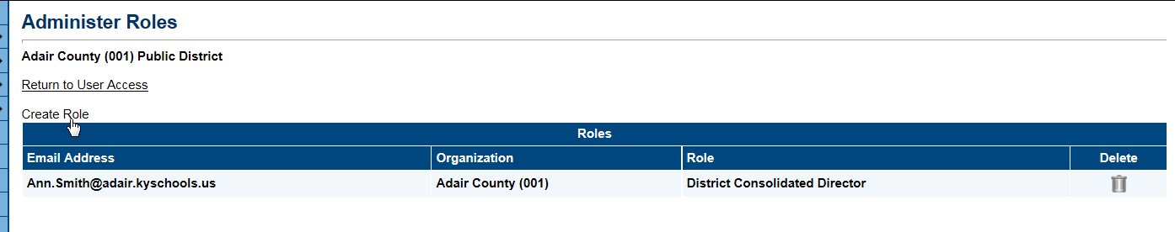  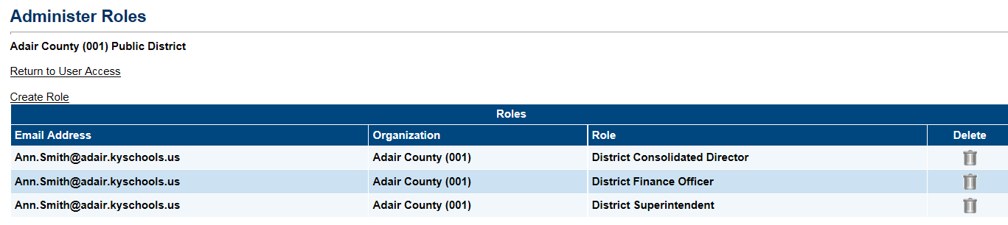
- Deleting a Role

- Search for the user.  - Click on the Administer Roles icon.  - On the Administer Roles page click on the Delete icon on the row of the role to be deleted. |  | 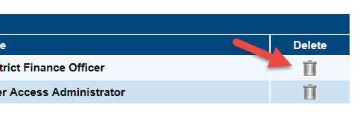
- Modifying an existing user’s information
- Users can modify their personal information and change their passwords by clicking on the name at the bottom of the main menu and making the necessary edits on the User Profile page. |  | 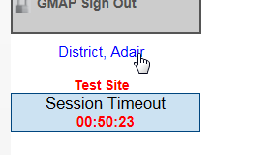  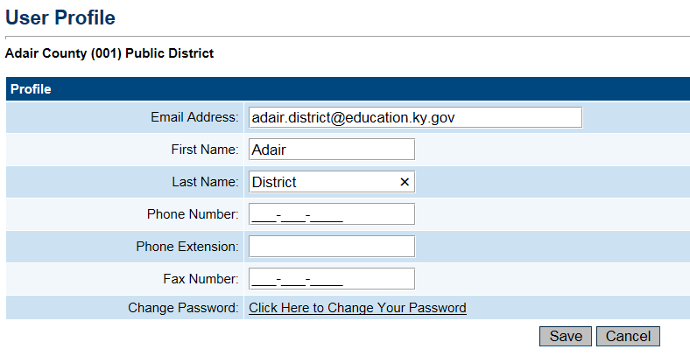
- A person with “User Access” role can also modify a user’s information by going to Administer on the menu, then User Access.
From the User Access page, search for the user.

- Deactivating Users
- Once added to GMAP, a user cannot be deleted. However, by removing all roles, the user will be deactivated and will not be able to perform any actions in the system.
- Search for the user. Select Delete All Role. (See graphic in item 4.)
- Working in Multiple Districts
- The KDE User Access administrators can assign roles for multiple districts for a user.  - Use the User Access Search page to find the user or create the new user.  - From the Create Roles select a district for the role and the role. (Leave School at ALL for users with funding application roles. The school is used only for users involved with the Planning Tool.)  - Repeat the process for other district roles. | 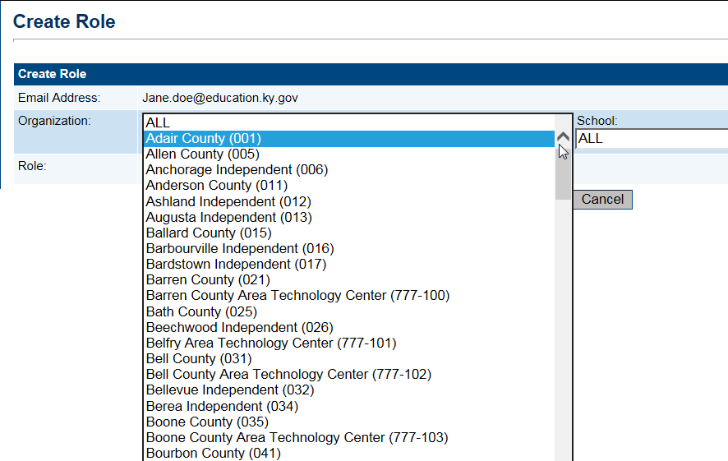  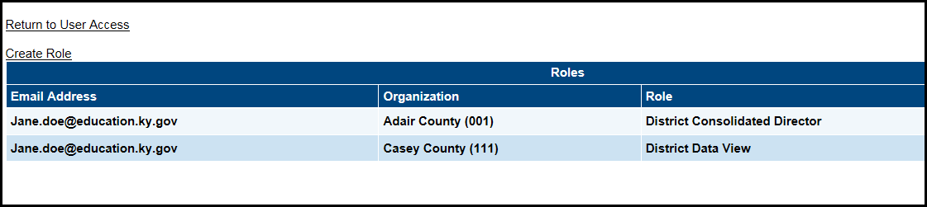
- The District User Access administrator can also assign a role within their district to any user who has a GMAP ID.  - Search for the user.  - Click on the Administer Roles icon.  - Assign the user a role within your district. Note: User roles in other districts will not appear for a District User Access administrator. | 